FINAL EXAMINATION
TIME ALLOWED: 90’
Subject: Linear Algebra.
No books allowed.

- Show that the complex number 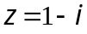 is a root of the equation
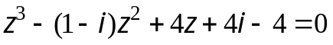 and hence find the other two roots.

- Find 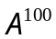, where 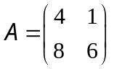 .
- Solve the system of equations: 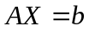, where 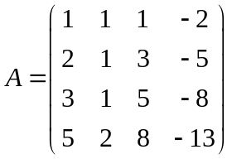, 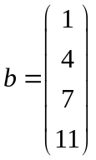

- Let 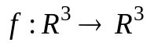 be a linear transformation.
Assume that
  - Find 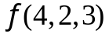.
  - Find the basic and dimension of Kerf.

- Let be a subspace of 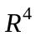. Find the dimension and one orthonormal basic for F.

- Determine all value(s) m such that rank(A) = 4, where
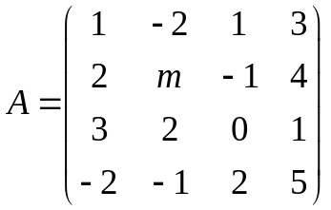

- Using the orthogonal diagonalization method, make a change of variables that transforms the quadratic form into the canonical form.

-----------------------  -----------------------

